Running Claude Code with Generative Engine - FREE TIER
Claude Code is powerful for developer workflows, agentic systems, and automation.
But by default, it assumes Anthropic as the backend provider.
What if you want to:
- Route through a custom OpenAI-compatible gateway? like in case of Generative Engine Free Tier

This became a real challenge for me.
I wanted to plug Claude Code with Generative Engine Free Tier models to try it for my initial learning purpose.
But it didn’t work.
Claude Code was sending requests in Anthropic’s API format, while our internal LLM server expected OpenAI-compatible requests. The result? Endpoint mismatches and failed inference calls.
Instead of replacing our infrastructure, I decided to understand the incompatibility and find a solution.
That’s what this article is about.
In this guide, we decouple Claude Code from its default backend and plug it into any OpenAI-compatible LLM hosting provider.
------------------------------------------------------------------------
By default, Claude Code is designed to communicate with an Anthropic-compatible API backend. Its request and response formats follow Anthropic’s API schema.

NOTE: If you are having a collaborative studio it will work and you dont need to follow this. There is a claude-code-playbook already released you can refer that.

We require:
- Integration with our own hosted LLM infrastructure, often exposed via OpenAI-compatible APIs.
Here lies the core challenge:
Claude Code sends inference requests in Anthropic API format, but Generative Engine free tier only support the OpenAI API format.
Because the request schemas and endpoints differ, Claude Code cannot directly communicate with an OpenAI-compatible server. The result is typically:
- 404 Not Found
- Route mismatch errors
- Model resolution failures
In short, the two systems speak different API “languages.”

Solution
To bridge this incompatibility, we introduce a protocol translation layer — a lightweight middleware that acts as an adapter between Claude Code and your LLM server.
Here’s what happens without the adapter:
- Claude Code sends an inference request in Anthropic format
- Your LLM server expects an OpenAI-compatible request
- The endpoint does not match
- The request fails with a 404 Not Found
The solution is to insert a middle layer that:
- Converts Anthropic-style requests → OpenAI-compatible requests
- Forwards them to your hosted LLM server
- Receives the OpenAI-style response
- Converts it back into Anthropic-compatible format
- Returns it to Claude Code
Lets look at the architecture diagram for this.
# Architecture Overview
Claude Code (Anthropic format)
↓
Protocol Adapter / Middleware
↓
OpenAI-Compatible LLM Server

This middleware can be implemented using:
- A lightweight FastAPI service
- LiteLLM as a translation gateway
- A custom proxy layer
- An enterprise API gateway with request transformation

With this approach, Claude Code remains unchanged — but your backend becomes fully customizable.
You gain:
- Vendor independence
- Infrastructure control
- Cost flexibility
- Model experimentation freedom

In essence, the adapter allows Claude Code to run on any OpenAI-compatible LLM backend, including self-hosted vLLM deployments or enterprise-grade hosting environments.
For this article we are going to use a very cool github repo that I found which does exactly what we talked about. (To avoid reinventing the wheel)

You can checkout their repo here (https://github.com/1rgs/claude-code-proxy.git). They have more than 3k stars (at the time of writing this article).

Assuming you already have an OpenAI compatible API server.
# Part 1: Configuring the middle layer
Clone this repo which works as a middle ware rerouting your claude code llm request to your hosted server.
``` bash
git clone https://github.com/1rgs/claude-code-proxy.git
```

After cloning make below change in server.py within the cloned repo:
change -> max_tokens = min(max_tokens, 16384) to -> max_tokens = min(max_tokens, 4000)

Then run:
Follow the instructions as per their README.md.
Start the server.
# Part 2: Setting up claude to route request through middle layer
``` bash
export ANTHROPIC_BASE_URL=http://localhost:8082
export ANTHROPIC_AUTH_TOKEN=123 # add any value here required just for confirming login through the base url for claude code
```
Without setting the ANTHROPIC_AUTH_TOKEN you may a warning as below on your claude code cli
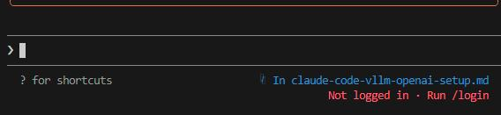
You can now start claude code and it will route the request through the middle layer to your server
```bash
claude
```
You should be getting the response on your claude code cli also on your middle layer you should be seeing some success response as shown below:

Above instructions are for claude code cli, in case you are trying to use claude code extension on vscode. Check steps below:
Download the claude code extension on vscode and install it.
Once installation is completed click on the settings icon as shown below.

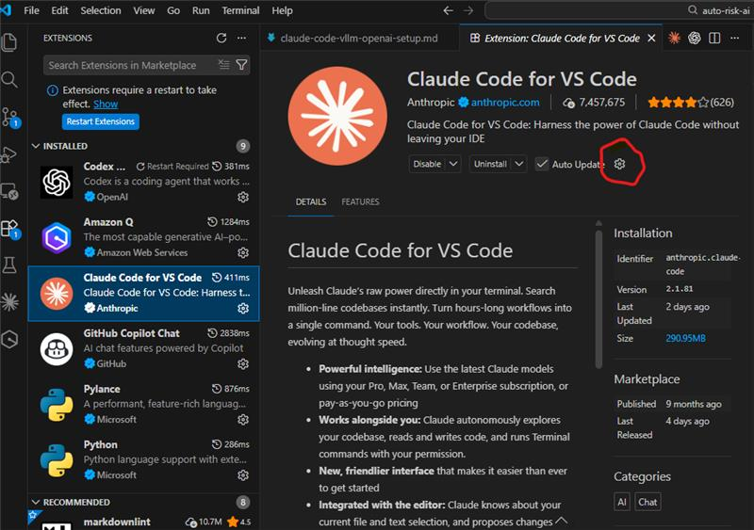

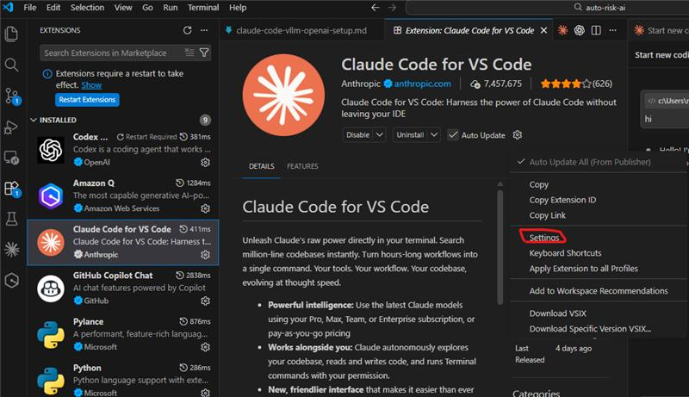

This opens up below page:
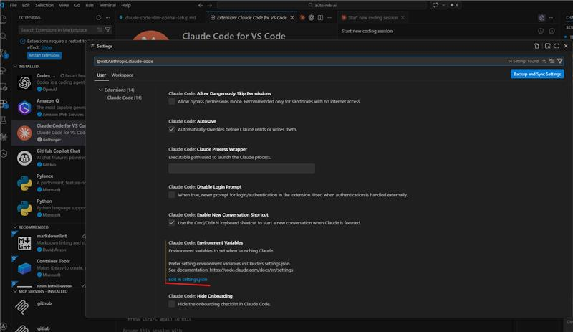

Click on Edit in settings.json as highlighted.
It should open the settings.json file and you can make changes in it.
Look for claudeCode.environmentVariables and add the two required environment variables.
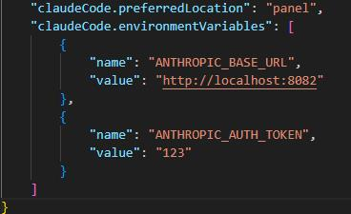

Now your claude code extension in vscode will work with Generative Engine Free Tier model you selected.
By introducing a lightweight compatibility layer, you can make Claude Code work seamlessly with Generative Engine Free Tier.

The key takeaway is simple:
- You don’t need to change your backend to use Claude Code.
- You just need to make the protocols speak the same language.
And once that bridge is in place, Claude Code becomes another powerful tool within your existing AI ecosystem.

NOTE:
- THIS FOR LEARNING PURPOSE ONLY FOR THOSE WHO WANT TO FAMILIARIZE WITH THE TOOL. GETTING A COLLABORATIVE TIER IS BETTER IN EVERY WAY DUE TO MODEL AVAILABIITY AND LIMIT ON API REQUESTS.
- THIS USES LITELLM, BUT DUE TO RECENT COMPROMIZATION OF THE LIBRARY IT IS ADVICED THAT YOU DOWNLOAD LITELLM < 1.82.7
- As per Lopes, Jorge Manuel's advice please use only anthropic models available from the Free Tier as shown in screenshot.
Hope this helps and unblocks those who are looking to learn.

